GLOBAL BUSINESS MANAGEMENT (TOP UP DEGREE) BSC (HONS)

It is important in the business world to understand entrepreneurial and creative approaches to business whilst abiding by policies, regulations, and ethics, from a management and marketing standpoint.

Swansea’s top up degree focuses on this - exploring organisations, their management strategies, and impacts of environment changes on a global scale, preparing students for careers in the global business market.

TUITION FEES
£18,650

WHY CHOOSE SWANSEA UNIVERSITY?
Business and Management Studies at Swansea University is ranked Top 150 (QS World University Rankings by Subject 2023).
Students are taught by a team of experienced lecturers from research, academic and industry backgrounds.
The School’s Careers team offers bespoke support to develop student career experience.

INDICATIVE PROGRAMME STRUCTURE




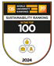
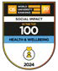
Project Management Innovation Management Strategic Implementation Global Business Project
Leadership
Enterprise and Creativity: Entrepreneurship in Practice Marketing Ethics
Academic and Professional Development

SCHOLARSHIPS AVAILABLE
APPLY FOR DEVELOPING FUTURES SCHOLARSHIP OF UP TO £2,000
Successful candidates can secure financial support for an academic year as well as the chance to gain valuable career-enhancing skills.

ENTRY REQUIREMENTS
Applicants will typically have studied a Foundation Degree, HND or equivalent, in a subject allied to business and/or management. Students will be admitted on the basis of recognition of Prior Learning (RPL).

As a guideline, below are examples of the overall grades we would typically accept, subject to a match in prior study
SQA - Grade B classification overall HND - Merit
Dazhuan - 75%

Non-native English speakers: 6.0 overall with no component less than 5.5 in IELTS or equivalent tests. For students who fall short of only the English language requirement there are a range of pre-sessional programmes that can be taken before starting the degree.

SCAN THE QR CODE TO EXPLORE THE COURSE


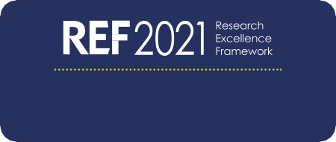


EMAIL: ADMISSIONS@SWANSEA.AC.UK

UNIVERSITY RANKINGS 2023

OF OUR RESEARCH ENVIRONMENT RATED WORLD-LEADING OR INTERNATIONALLY EXCELLENT
100%

